ROTARY INTERNATIONAL YOUTH EXCHANGE COMMITTEE
District 5160 – Northern California
FIRST QUARTER REPORT - DUE September 15

These reports are to be e-mailed to the Youth Exchange Committee Outbound Coordinator at D5160YEXOutbound@gmail.com. Please answer all questions fully and honestly so we can understand your particular circumstances.
Reminder! If you have any concerns that need immediate attention, do not wait for your quarterly report to contact your in country counselor or your outbound coordinator.
First Quarter Report
You have now been in your host country for a month; everything is new! Remember – it’s not right; it’s not wrong; it’s just different!
We are interested in your experiences to date, and look forward to reading your responses to these questions:
- TRAVEL – Tell us about your travel experience to your host country and your first few days/weeks with your host family (Visa process, flights, greeting at the airport, first few nights). Please highlight what went well and what could have gone better. Did you go through the first night questions? Is there anything that concerns you?
- ROTARY – Describe Rotary in your District, (ie: your counselor, [have you met?], your Club, inbound orientation, club attendance requirements) and any special events you are looking forward to attending.
- LANGUAGE CAMP – Describe your language camp, if you had one. Could you have been better prepared for camp? What would you have done differently prior to arriving at camp?
- SCHOOL – Describe a typical day at school (classes, friends, teachers, other exchange students). What were your first impressions of your host country school as compared to your school in California? What are you looking forward to and does anything concern you? Was language testing required before entering school?
- INTERACT CLUB/COMMUNITY SERVICE – If your school has an Interact Club, get involved! Community Service and friends; a great combination!
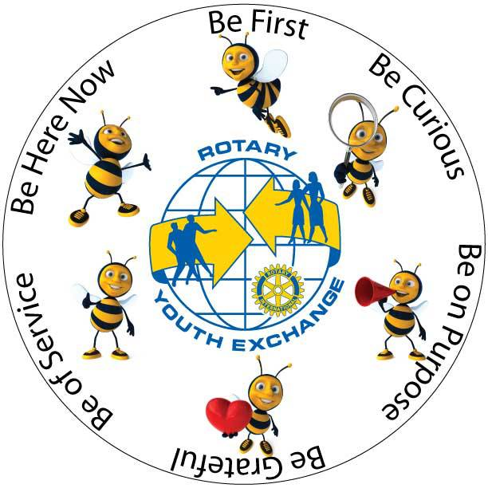
- HOST FAMILY – What have you learned about your host family (occupation, ages, hobbies, Rotarians, siblings)? Did your host family ask about your interests? As most schools don’t offer sports and clubs, are they trying to connect you with a local club where you can participate? How is your relationship with your host family? Are there any issues with your host family that concern you? Do you feel comfortable talking to your in country Counselor about any problems that you may experience?
- What else? What are we forgetting to ask?

Please attach three photos that I can share with your sponsoring Club
here in the US – let me know what the picture is of and why you chose
to include it! Thanks!

