ROTARY INTERNATIONAL YOUTH EXCHANGE COMMITTEE
District 5160 – Northern California
SECOND QUARTER REPORT - DUE December 15

These reports are to be e-mailed to the Youth Exchange Committee Outbound Coordinator at D5160YEXOutbound@gmail.com. Please answer all questions fully and honestly so we can understand your particular circumstances.
Reminder! If you have any concerns that need immediate attention, do not wait for your quarterly report to contact your in country counselor or your outbound coordinator.
Second Quarter Report
You have now been in the country for approximately four months. You have either moved to your next host family or are about to move.
We are interested in your experiences to date, and look forward to reading your responses to these questions:
- Tell us about your greatest surprise living in a different culture – differences and/or similarities to California, family life, school – whatever…. Was it a pleasant surprise, or one that required you to re-evaluate how you’ve thought about things?
- Give us some insight into your new relationships with your host families, school friends and Rotary Club. Have you changed host families? How was the transition? Who do you hang out with at school? How is attending school on a daily basis? How involved are you with your Rotary Club/Counsellor?
- Community Service Projects are a great way to get involved in your community and make new friends. What community service projects have you been involved with? What was the most rewarding part of your experience?
- Christmas is just around the corner, and typically this is the time most students feel homesick. If you are experiencing homesickness, how are you handling it? Are you remembering the Bee’s? Let us know what works for you.
- Looking forward, what are you and your friends/host family planning for the spring? Are there any Rotary events coming up or school/host family trips? Knowing that you will need to book your return flights after Christmas, do you have a sense of what the year-end dates might look like (i.e.: When does school let out? Is there a year-end tour/trip you are planning on taking with the other exchange students?)
- Reflecting on the past four months, is there anything you would have done differently? Could Rotary have done anything differently to make the experience better? When you help at the March Outbound Orientation next year, what will you share with the next student going to your country?
- Please describe a challenge that you’ve had. What was it? Who helped you through it? Was it resolved in a way that worked for everyone? What will you do differently or the same when confronted with another challenge?
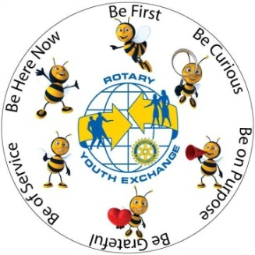
- What else? What are we forgetting to ask?

Please attach three photos that I can share with your sponsoring Club
here in the US – let me know what the picture is of and why you chose
to include it! Thanks!

