How a summer day changed everything
By Andrea Shirey
Posted on December 10, 2015 by Rotary International
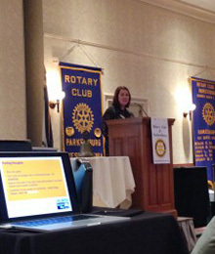
On a summer day at my weekly Rotary Club meeting, a simple “yes” changed everything. A series of events and conversations over several weeks had led a fellow Rotarian to ask me if our family would host an exchange student. Somehow, the word “yes” fell from my lips as my brain lagged behind just long enough to realize I was committed. Soon, the questions formed:
What if the student is weird? What if my kids don’t get along with her? What if she won’t eat anything I cook and she dislikes America because of me? The doubts were endless, the fears considerable.

A few weeks of shopping to turn a spare bedroom into a guest room and many prayers later, our student joined our family on a Monday afternoon. That was in August.
Our simple answer of yes to hosting a Rotary Youth Exchange student has brought us an experience we didn’t even know we needed. From nights of dinner conversation, TV-watching on the couch, and even a road trip under our belt, it’s remarkable how quickly another person can become part of your day-to-day life.
We have laughed over words that do not quite translate. We have discovered parts of life where country of origin has no bearing, like deep sorrow over the death of a loved one. We have let down walls and there is no turning back. We chose to not only open our home but to also open our hearts to this young girl who dreamed of studying in America someday.
We don’t talk about the end of the year or the inevitable difficult goodbye that will come sooner than we like. We are choosing to live each day in gratitude and to embrace the perspective that our host daughter brings to our American life.
We’re not special people or uniquely qualified to serve as a Rotary host family. I am simply one mother in the United States in awe of another mother in Italy whose selfless act to sacrifice 10 months without her daughter so that she could live a lifetime of experiences in America inspires me every day.

